Follow this procedure to install database:

Step 1: Provide the server space for stored the payroll database.
Exp: network [T:]
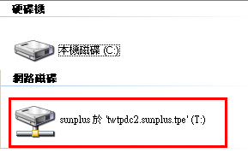

Step 2: Create a new folder, assign access rights allowing users Read/Write
Exp: [T:\PublicFolder\Payroll-DB]
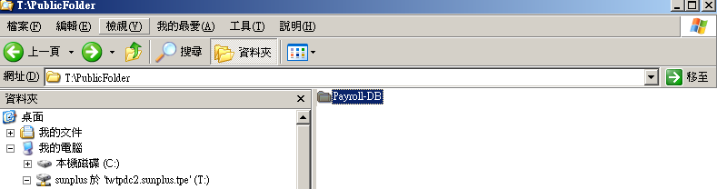

Step 3: Copy the [Payroll.mdb] from [{payroll}\DB\] to [T:\PublicFolder\Payroll-DB]
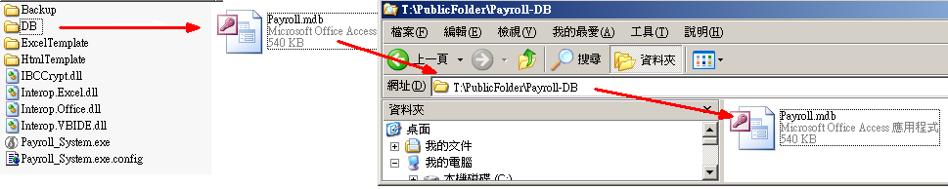

Step 4: Open the Payroll_System.exe.config file and find and replace the string
“ <add key="DBAbsolutePath" value=""/> “ with “ <add key="DBAbsolutePath" value="new server path"/> “
Exp: <add key="DBAbsolutePath" value="T:\PublicFolder\Payroll-DB"/>
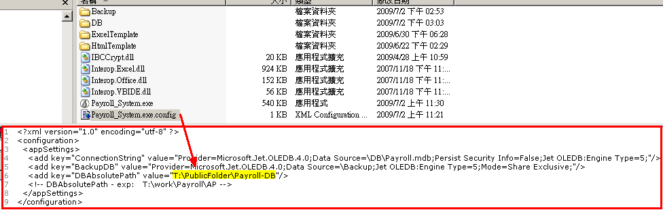

Step 5: Save file

Run [Payroll_System.exe] to test. Username: admin / password default: 000000
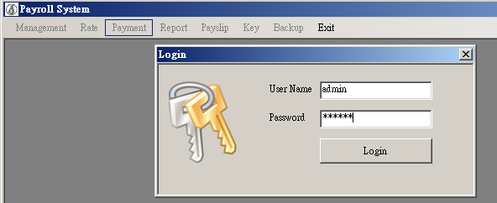
Login….
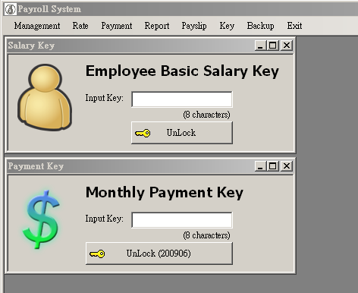

Done.

